

Subject Name : ServiceNow Administrator (NM1051)
Project Title : Calculating Family Expenses using ServiceNow

Team ID : NM2025TMID0865
Team Leader : Vetriselvan K
Team Member : Naveen S
Team Member : Veeramani C
Team Member : Akith M

1.Objective :
The project aims to develop a comprehensive expense calculation system using ServiceNow. This system will enable users to track and manage family expenses efficiently. It will include features such as expense categorization, budget setting, real-time tracking, and reporting capabilities. Utilizing ServiceNow's robust platform, the project will ensure seamless integration, user-friendly interface, and scalability to accommodate varying family sizes and financial complexities. The end goal is to empower users with the tools they need to make informed financial decisions and promote financial well-being within the family unit.

2.Introduction :
The Calculating Family Expenses using ServiceNow project aims to utilize the ServieNow platform to simplify and automate the process of managing household finances. In today’s fast-paced lifestyle , families often struggle to monitor and control their daily ,monthly and annual expenses effectively.This project leverages ServiceNow’s powerful workflow automation , data management and reporting capabilities to build a centralized system for recording , categorizing and analyzing family expenses.

3.Implementation Steps :
Step 1 : Setting Up ServiceNow Instance
- Sign up for a developer account on the ServiceNow Developer site “https://developer.servicenow.com”.
- Once logged in, navigate to the "Personal Developer Instance" section.
- Click on "Request Instance" to create a new ServiceNow instance.
- Fill out the required information and submit the request.
- You'll receive an email with the instance details once it's ready.
- Log in to your ServiceNow instance using the provided credentials.
- Now you will navigate to the ServiceNow.

Step 2 : Creation of New Update Set
- Go to All >> In the filter search for Local Update set > click on New.
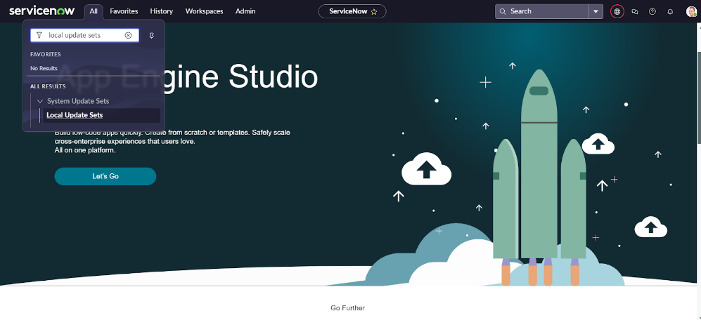
- Enter the Details as:
Name : Family Expenses
- Then click on Submit and Make current.
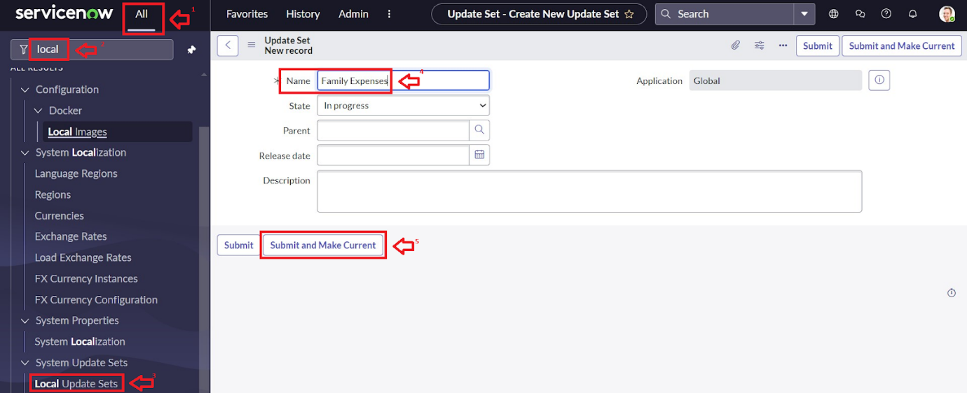
Step 3 : Creation Of Family Expense Table
- Go to All > In the filter search for Tables > click on New.
- Enter the Details:
Label : Family Expenses
Name : Auto-Populated
New menu name : Family Expenditure
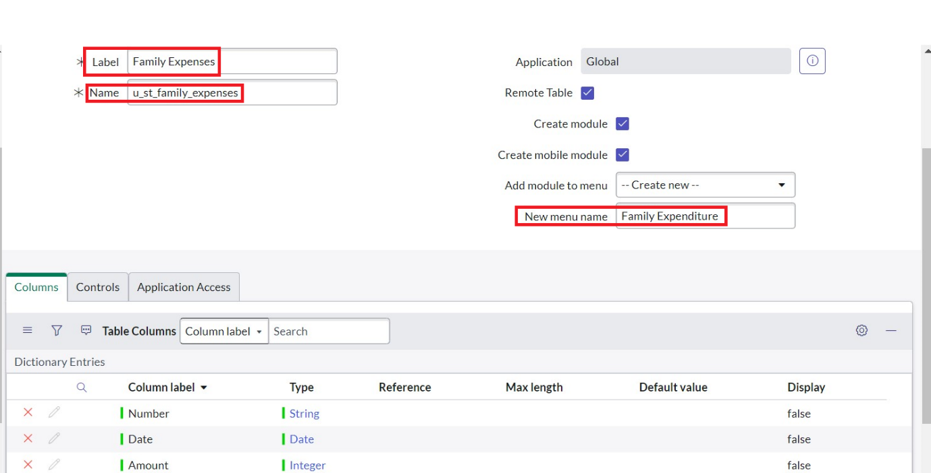
- Go to the Header and right click there>> click on Save.

Step 4 : Creation Of Relationship Between Family Expenses and Daily Expenses Tables.
- Go to All >> In the filter search for Relationships >> Open Relationships
- Click on New.
- Enter the details:
Name : Daily Expenses
Applies to table : Select Family Expenses
Daily Expenses : Select Daily Expenses
- Click Save.
Step 5 : Configuring Related Lists on Family Expenses
- Go to All >> In the filter search for Family Expenses >> Open Family Expenses
- Click on New
- Go to the Header and right click there>> click on Configure >> Select Related Lists
- Add Daily Expenses to the Selected Area.
- Click on Save

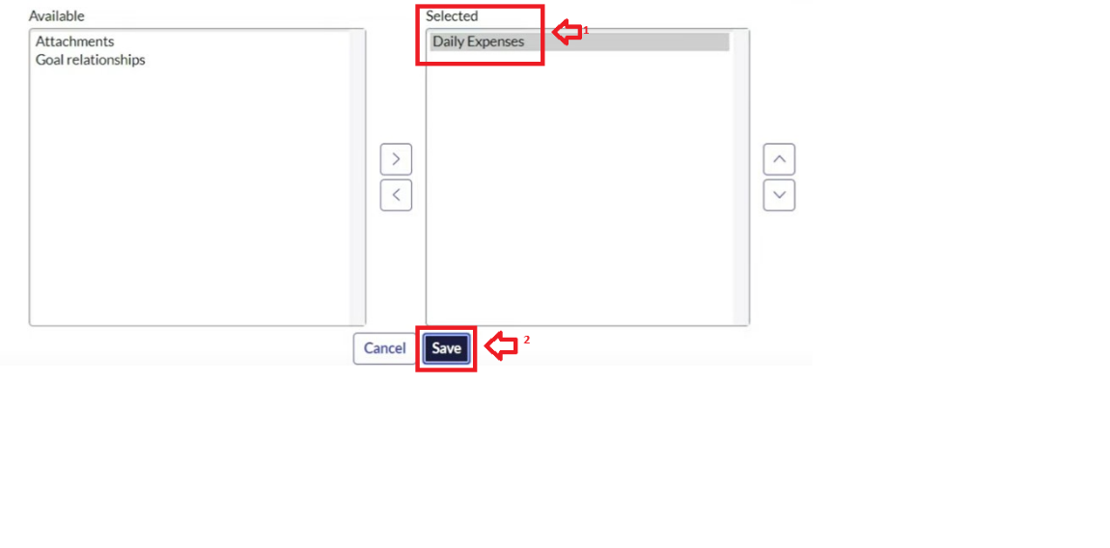
Step 6 : Creation of Business Rules.
- Go to All >> In the filter search for Business Rules.
- Under System Definition Select Business Rules then click on New.
- Enter the Details:
Name : Family Expenses BR
Table : Select Daily Expenses
Check Advanced
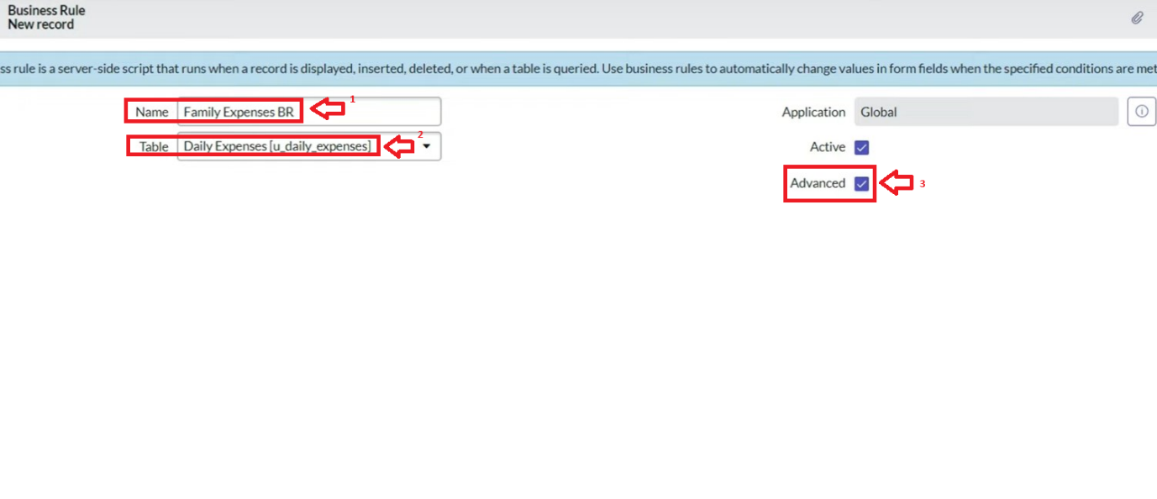
- In when to run Check Insert and Update
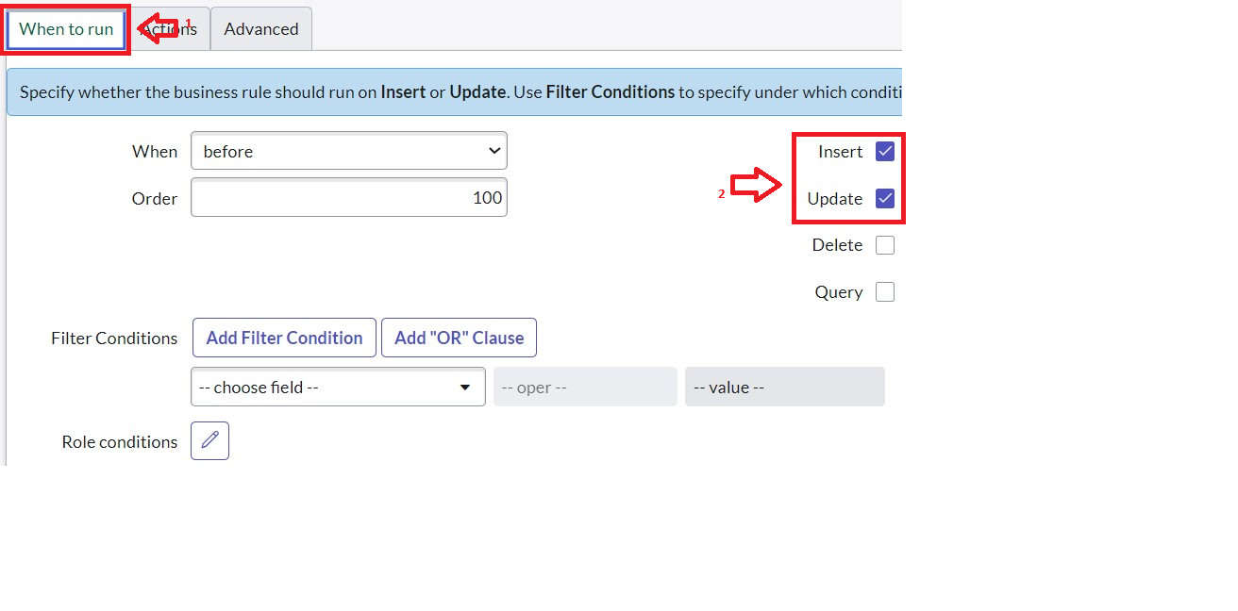
- In Advance(we write the code): Write the below code >>

(function executeRule(current, previous /*null when async*/) {

var FamilyExpenses = new GlideRecord('u_family_expenses');
FamilyExpenses.addQuery('u_date',current.u_date);
FamilyExpenses.query();
if(FamilyExpenses.next())
{
FamilyExpenses.u_amount += current.u_expense;
FamilyExpenses.u_expense_details += ">"+current.u_comments+":"+"Rs."+current.u_expense+"/-";
FamilyExpenses.update();
}
else
{
var NewFamilyExpenses = new GlideRecord('u_family_expenses');
NewFamilyExpenses.u_date = current.u_date;
NewFamilyExpenses.u_amount = current.u_expense;
NewFamilyExpenses.u_expense_details += ">"+current.u_comments+":"+"Rs."+current.u_expense+"/-";
NewFamilyExpenses.insert();
}

})(current, previous);
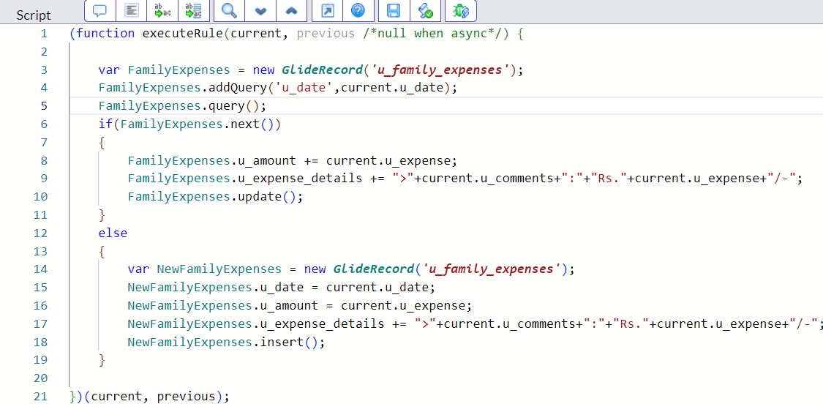
- Go to the Header and right click there>> click on Save.
Step 7 : Configuring The Relationship
- Go to All >> In the filter search for Relationships >> Open Relationships.
- In that, open Daily Expenses Relationship.
- For Applies to table : Select Family Expenses.
- In Query with : write the below Query.
(function refineQuery(current, parent) {
// Add your code here, such as current.addQuery(field, value);
current.addQuery('u_date',parent.u_date);
current.query();
})(current, parent)
- Click on Update.
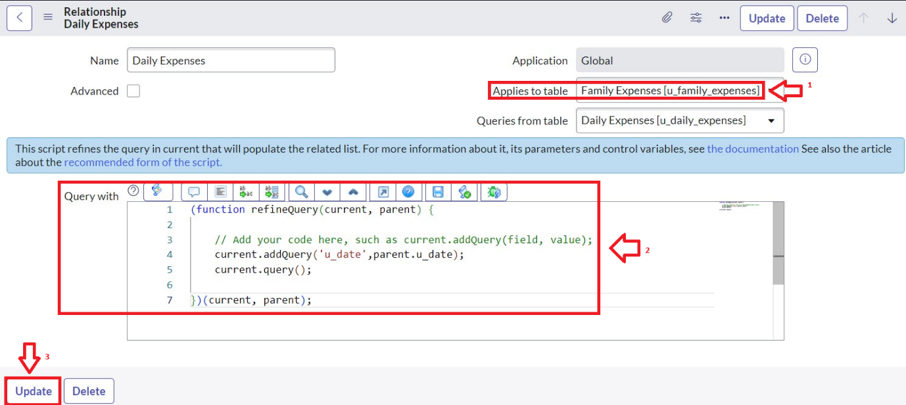

Step 8 : Results and Output
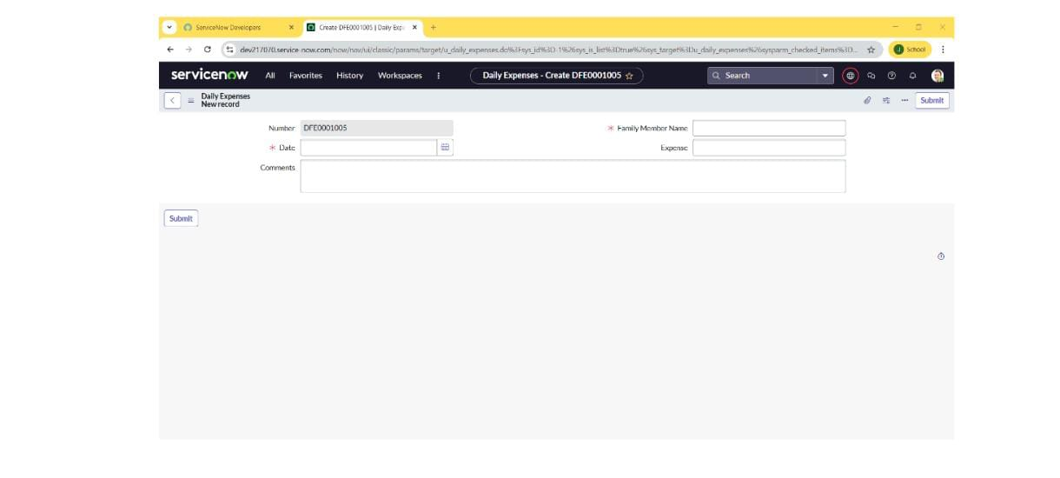
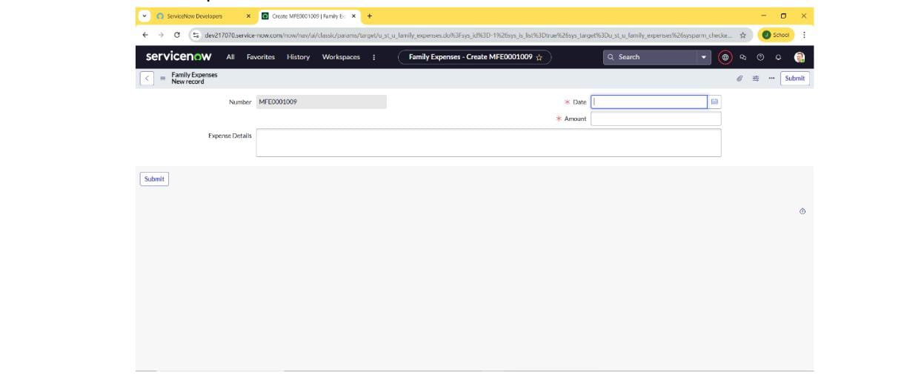

4.Conclusion :
The “Calculating Family Expenses using ServiceNow” project successfully demonstrates how the ServiceNow platform can be utilized beyond enterprise IT solutions to address everyday financial management needs. By automating the process of recording, categorizing, and analyzing expenses, the application provides an efficient and user-friendly way for families to monitor their spending habits and maintain better control over their budgets. The project not only enhances financial awareness but also showcases the flexibility and power of ServiceNow in developing customized, practical solutions for real-life problems. Ultimately, this initiative contributes to promoting smarter financial planning and informed decision-making within households.

